Compiler Design Lab
Date: 9-1-2026 | Name: S Vishwajith
Assignment No.: 5 | Register No.: 23BCE1145

Aim:
To write a C++ program that parses the given LL (1) grammar: E->E+T/T; T->T*F/F; F->(E)/id; and prints the first(), follow(), parse table and the stack trace, and check if the string “(id+id)*id” is accepted by the grammar or not.

Algorithm:
- Eliminate left recursion present in the given grammar.
- Find first() for all non-terminals.
- Using first(), find follow() for all non-terminals.
- Using first() and follow(), construct the parse table.
- Using this parse table, check whether the string can be accepted or not, and print the trace for each step.

Code:
#include <iostream>
#include <vector>
#include <string>
#include <map>
#include <set>
#include <iomanip>
using namespace std;

vector<pair<char, string>> get_grammar()
{
return {
{'E', "TA"},
{'A', "+TA"},
{'A', "e"},
{'T', "FB"},
{'B', "*FB"},
{'B', "e"},
{'F', "(E)"},
{'F', "id"}};
}

map<char, set<string>> FIRST, FOLLOW;
map<char, map<string, string>> TABLE;

bool isNonTerminal(char c)
{
return c >= 'A' && c <= 'Z';
}

void computeFIRST(vector<pair<char, string>> &G)
{
bool changed = true;
while (changed)
{
changed = false;
for (auto &prod : G)
{
char A = prod.first;
string rhs = prod.second;

if (rhs == "e")
{
if (FIRST[A].insert("e").second)
changed = true;
continue;
}

for (int i = 0; i < rhs.length(); i++)
{
char X = rhs[i];

if (isNonTerminal(X))
{
for (auto t : FIRST[X])
if (t != "e")
if (FIRST[A].insert(t).second)
changed = true;

if (FIRST[X].count("e") == 0)
break;
}
else
{
if (X == 'i')
FIRST[A].insert("id");
else
FIRST[A].insert(string(1, X));
break;
}
}
}
}
}

void computeFOLLOW(vector<pair<char, string>> &G)
{
FOLLOW['E'].insert("$");

bool changed = true;
while (changed)
{
changed = false;
for (auto &prod : G)
{
char A = prod.first;
string rhs = prod.second;

for (int i = 0; i < rhs.length(); i++)
{
char B = rhs[i];
if (!isNonTerminal(B))
continue;

bool epsilonTrail = true;

for (int j = i + 1; j < rhs.length(); j++)
{
epsilonTrail = false;
char C = rhs[j];

if (isNonTerminal(C))
{
for (auto t : FIRST[C])
if (t != "e")
if (FOLLOW[B].insert(t).second)
changed = true;

if (FIRST[C].count("e"))
epsilonTrail = true;
else
break;
}
else
{
if (C == 'i')
FOLLOW[B].insert("id");
else
FOLLOW[B].insert(string(1, C));
break;
}
}

if (epsilonTrail || i == rhs.length() - 1)
for (auto t : FOLLOW[A])
if (FOLLOW[B].insert(t).second)
changed = true;
}
}
}
}

set<string> FIRST_of_string(string s)
{
set<string> result;
for (int i = 0; i < s.length(); i++)
{
char X = s[i];

if (isNonTerminal(X))
{
for (auto t : FIRST[X])
if (t != "e")
result.insert(t);
if (FIRST[X].count("e") == 0)
break;
}
else
{
if (X == 'i')
result.insert("id");
else
result.insert(string(1, X));
break;
}
}
return result;
}

void buildParsingTable(vector<pair<char, string>> &G)
{
for (auto &prod : G)
{
char A = prod.first;
string alpha = prod.second;

auto f = FIRST_of_string(alpha);

for (auto t : f)
TABLE[A][t] = alpha;

if (f.count("e"))
for (auto b : FOLLOW[A])
TABLE[A][b] = alpha;
}
}

vector<string> tokenize(string s)
{
vector<string> tokens;

for (int i = 0; i < s.length();)
{
if (i + 1 < s.length() && s.substr(i, 2) == "id")
{
tokens.push_back("id");
i += 2;
}
else
{
tokens.push_back(string(1, s[i]));
i++;
}
}
return tokens;
}

int parse(string input)
{
input += "$";

vector<string> stk = {"$", "E"};
int i = 0;

cout << left
<< setw(20) << "Stack"
<< setw(20) << "Input"
<< "Action" << endl;
cout << "----------------------------------------------------------" << endl;

while (true)
{
string stackStr;
for (auto &s : stk)
stackStr += s;

cout << left
<< setw(20) << stackStr
<< setw(20) << input.substr(i);

string X = stk.back();

if (X == "$" && input[i] == '$')
{
cout << "Accept\n";
return 0;
}

string a;
if (i + 1 < input.length() && input.substr(i, 2) == "id")
a = "id";
else
a = string(1, input[i]);

if (!isNonTerminal(X[0]))
{
if (X == a)
{
stk.pop_back();
i += (a == "id" ? 2 : 1);
cout << "Match " << a << "\n";
}
else
{
cout << "Error\n";
return 1;
}
}
else
{
if (TABLE[X[0]].count(a) == 0)
{
cout << "Error\n";
return 1;
}

stk.pop_back();
string prod = TABLE[X[0]][a];

if (prod != "e")
{
auto tokens = tokenize(prod);
for (int k = tokens.size() - 1; k >= 0; k--)
stk.push_back(tokens[k]);
}

cout << X << " --> " << prod << "\n";
}
}
}

int main()
{
auto grammar = get_grammar();

computeFIRST(grammar);
computeFOLLOW(grammar);
buildParsingTable(grammar);

cout << endl
<< "First():" << endl;
for (auto &p : FIRST)
{
cout << "first(" << p.first << ") = { ";
for (auto &x : p.second)
cout << x << " ";
cout << "}\n";
}

cout << endl
<< "Follow():" << endl;
for (auto &p : FOLLOW)
{
cout << "follow(" << p.first << ") = { ";
for (auto &x : p.second)
cout << x << " ";
cout << "}\n";
}

cout << endl
<< "Parsing Table:" << endl;
for (auto &r : TABLE)
for (auto &c : r.second)
cout << "map[" << r.first << "," << c.first << "] = " << r.first << " --> " << c.second << endl;

string input;
cout << endl
<< "Enter input string: ";
cin >> input;

int res = parse(input);
cout << endl
<< ((res == 0) ? "String is accepted." : "String is rejected.") << endl;
}

Input/Output:
First():
first(A) = { + e }
first(B) = { * e }
first(E) = { ( id }
first(F) = { ( id }
first(T) = { ( id }

Follow():
follow(A) = { $ ) }
follow(B) = { $ ) + }
follow(E) = { $ ) }
follow(F) = { $ ) * + }
follow(T) = { $ ) + }

Parsing Table:
map[A,$] = A --> e
map[A,)] = A --> e
map[A,+] = A --> +TA
map[A,e] = A --> e
map[B,$] = B --> e
map[B,)] = B --> e
map[B,*] = B --> *FB
map[B,+] = B --> e
map[B,e] = B --> e
map[E,(] = E --> TA
map[E,id] = E --> TA
map[F,(] = F --> (E)
map[F,id] = F --> id
map[T,(] = T --> FB
map[T,id] = T --> FB

Enter input string: (id+id)*id
Stack Input Action
----------------------------------------------------------
$E (id+id)*id$ E --> TA
$AT (id+id)*id$ T --> FB
$ABF (id+id)*id$ F --> (E)
$AB)E( (id+id)*id$ Match (
$AB)E id+id)*id$ E --> TA
$AB)AT id+id)*id$ T --> FB
$AB)ABF id+id)*id$ F --> id
$AB)ABid id+id)*id$ Match id
$AB)AB +id)*id$ B --> e
$AB)A +id)*id$ A --> +TA
$AB)AT+ +id)*id$ Match +
$AB)AT id)*id$ T --> FB
$AB)ABF id)*id$ F --> id
$AB)ABid id)*id$ Match id
$AB)AB )*id$ B --> e
$AB)A )*id$ A --> e
$AB) )*id$ Match )
$AB *id$ B --> *FB
$ABF* *id$ Match *
$ABF id$ F --> id
$ABid id$ Match id
$AB $ B --> e
$A $ A --> e
$ $ Accept

String is accepted.
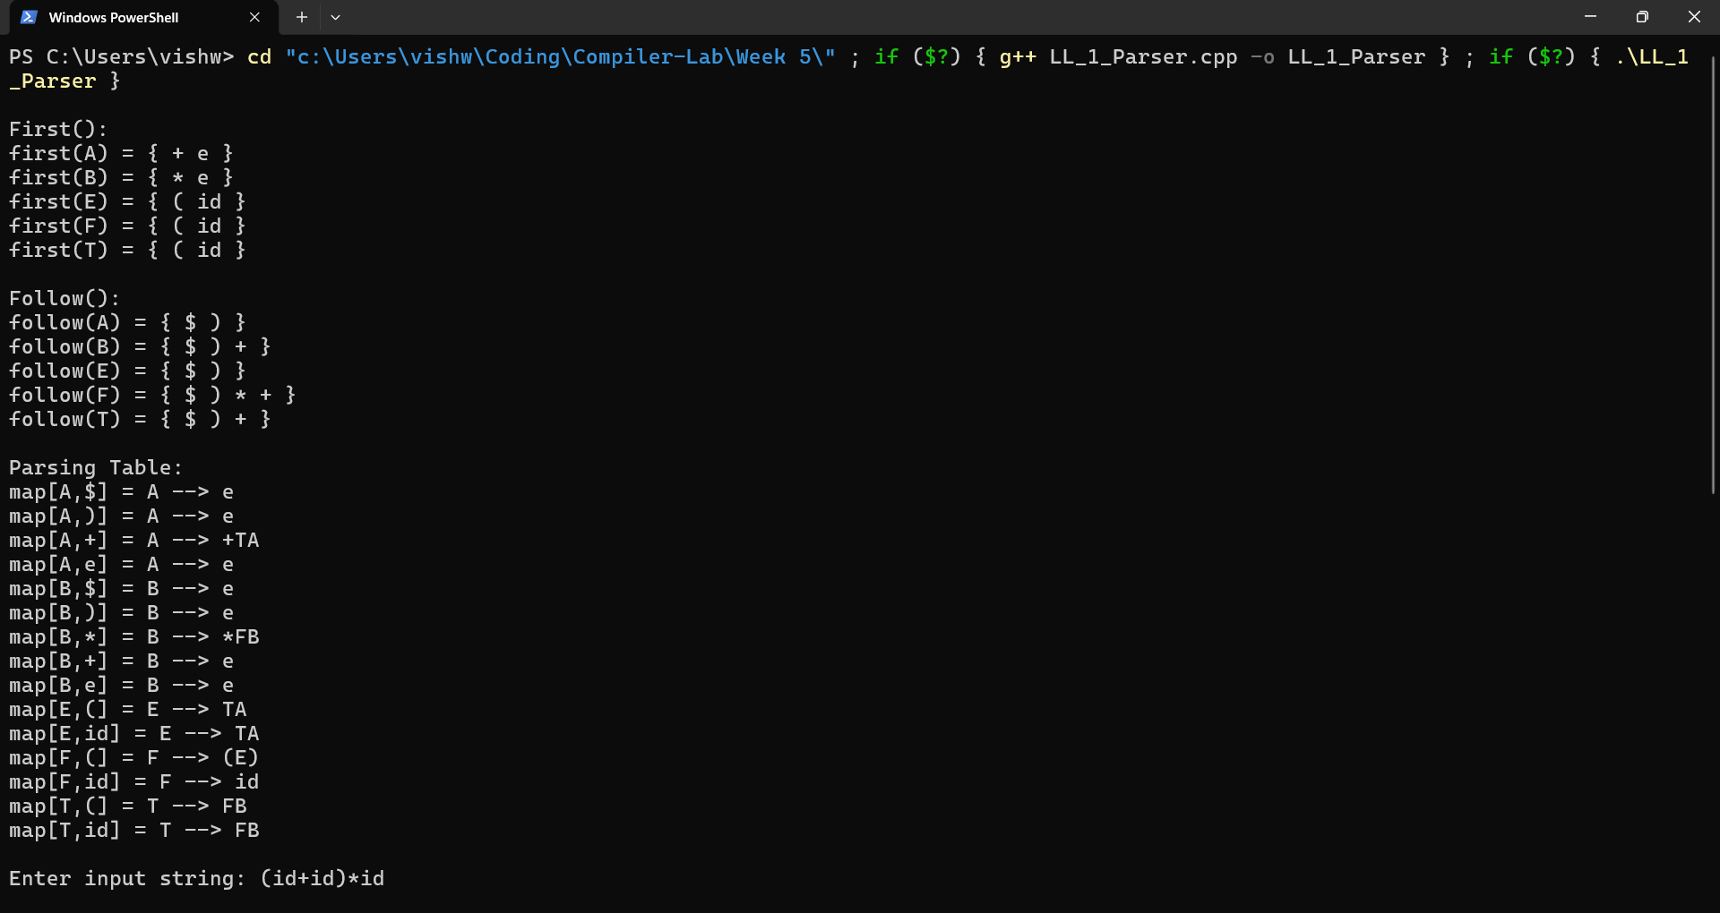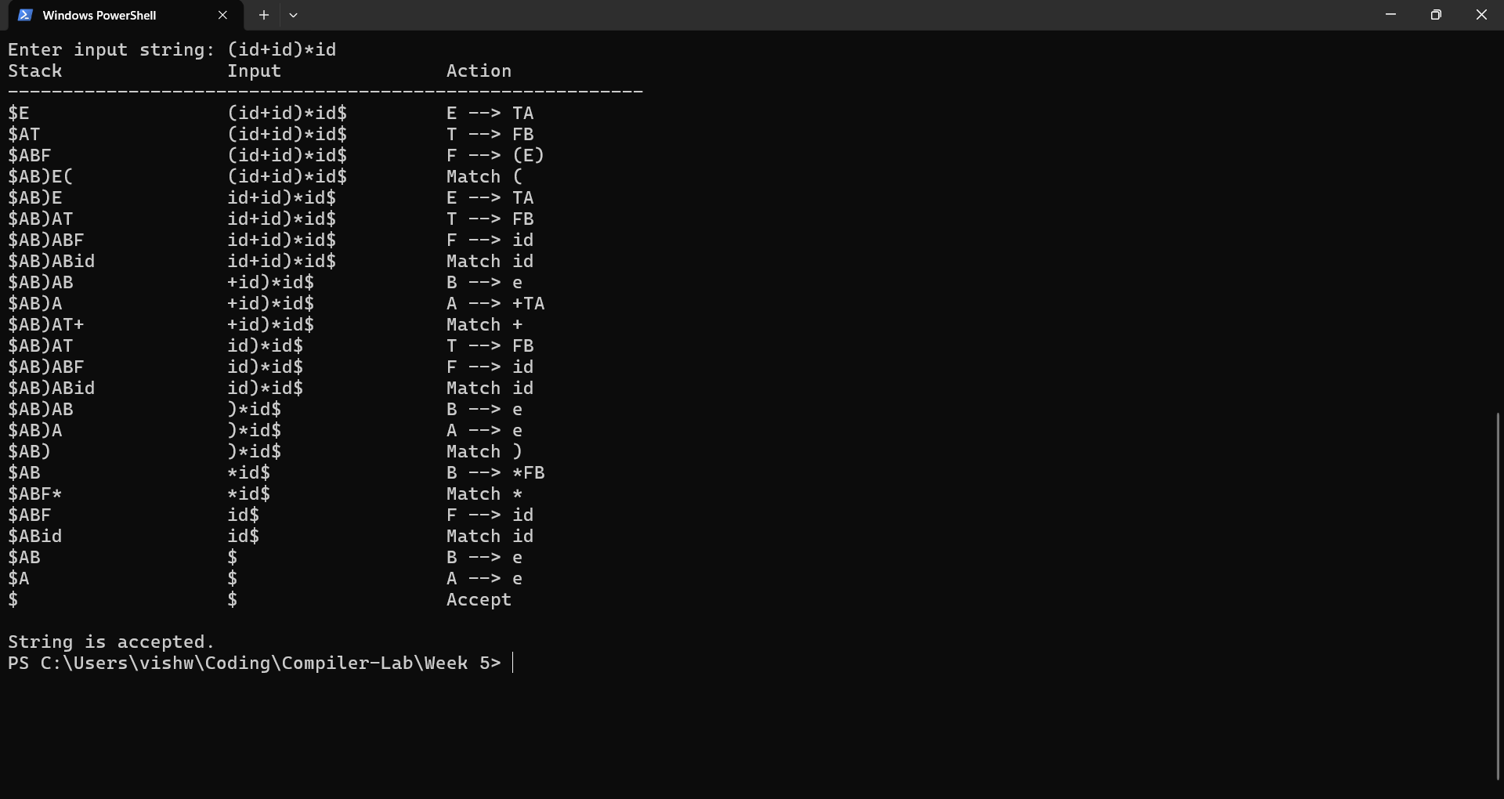

Result:
The C++ program that parses the given LL (1) grammar: E->E+T/T; T->T*F/F; F->(E)/id; and prints the first(), follow(), parse table and the stack trace, and check if the string “(id+id)*id” is accepted by the grammar or not was successfully run and the results were verified.

